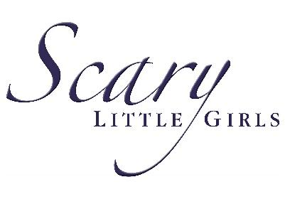
Celebrate the power of women in midlife at Mayven Festival’s spring folk festival
Renowned feminist theatre company Scary Little Girls has announced the full programme for their spring festival celebrating the power of women in midlife - and tickets are now on sale.
Running from 10-17 May 2024, the Mayven Festival will be taking over venues across Cornwall, bringing a folk theme to this year’s spring offering.

Working with female artists and performers and championing the work of female writers, directors and producers, the Mayven festival is a spectacular celebration of the power of women in midlife and will bring an uplifting celebration of the freedom it brings this spring.

From storytelling events to folk music performances, from celebrations of famous female artists to cabaret shows, the Scary Little Girls team will tell important stories in their own inimitable way.

Join the Festival this May and become a part of the celebration of the power and strength of women.
Rebecca Mordan, artistic director of Scary Little Girls, said: “As fans from previous festivals will know, the Mayven represents a dynamic time in a woman’s life - a time when all of the experience and prowess she brings comes together in a really exciting way.”
She added; “We are very excited about the women we have brought together to be part of the Mayven festival this spring. We have artists from all over Cornwall – like queens of the scene Angeline Morrison and Jenny Beare – and we’re also working with women from as far away as London and Cumbria, up-and-coming stars of the modern folk scene like Flo Perlin.
“We are staging unique events that not only blend the skills of our performers but shine a light on some of the areas that Cornwall excels at, like spoken word and circus performance. This year’s Spring Mayven will harness and showcase the amazing power of women and their relationship with music and movement.”
Discover some of the festival highlights here:
Cabaret with Claws
The Poly, Falmouth
Friday 10 May

Mixing wicked humour and eclectic jazz and cabaret, interspersed with jaw-dropping circus in solo performances and ensemble creations, Charlie Bicknell’s shows receive critical acclaim and, just as importantly, foot-stamping encores. In ‘Cabaret with Claws’ Charlie and cohort Louise Innes present twisted takes on familiar themes, with Tim Minchin, Phil Nichols and Bonnie Tyler influences thrown in. Tickets for this show are available directly from The Poly.

Feminist as Folk
Various venues across Cornwall
Saturday 11 May – Sunday 12 May
Thursday 16 – Friday 17 May
From the company that brought you Best of the Fest and A Madcap Mayven Cabaret, this one-off event combines folk music, spoken word and circus with Scary Little Girls’ trademark warmth and hilarity! Expect performances from queens of the scene – including Jenny Beare, Angeline Morrison, Flo Perlin, Splendid Sisters and Femmes de la Mer - with different performers at each venue.
All hosted by Glastonbury’s Bunny Morethan (aka Rebecca Mordan) and suffused with poems, sketches, comedy and feats of the fabulous from Scary Little Girls’ Radical Rep and Cirque du Ciel in an unforgettable evening that’s Feminist as Folk!

The Late Great Wake
Monday 13 May
Helston

Ever wondered how a live podcast is made and wanted to be in the audience for one? Join Rebecca Mordan (SLG founder), Lorna Partington (Off the Shelf Literature Festival prize winner) and Source Radio in this live-recorded podcast as they pay tribute to Frida Kahlo.

Folk Storytelling
Tuesday 14 May and Wednesday 15 May
Penzance and Tintagel

Join Scary Little Girls for a magical evening of storytelling, using extracts from the most recommended books in the shop with themes of witches, ghosts and supernatural women.
As always with our storytelling events, we’ll be combining wonderful performers and a welcoming environment with music, pathos, wit and song.

Common Ground: Greenham Women Everywhere
Wednesday 15 May and Saturday 18 May
Porthtowan and Golant

Join us for an evening hearing all about life at the Greenham Common Women’s Peace Camp. Hear songs and stories that bring the camp to life as we reflect on the impact of the camp 40 years on.

Greenham child and author Rebecca Mordan will introduce her book ‘Out of the Darkness: Greenham Voices 1981 – 2000’ sharing the impact her early experiences of the camp have had on her life. A screening of Carry Greenham Home will transport you back to the early days of Greenham with Beeban Kidron and Amanda Richardson’s fly-on-the-wall masterpiece, shot whilst they lived at Greenham in 1982-83.

The evening will be a chance to see the Greenham movement in all its glory, grim, grit and enduring grandeur.

This project is part-funded by the UK Government through the UK Shared Prosperity Fund. The Mayven Festival Cornwall is part of a body of artistic work including festivals, tours and new commissions Scary Little Girls are set to deliver until April 2025 with the £296,200 grant from the UK Government, received through the UK Shared Prosperity Fund which is part of a £4.4m investment in a cultural events and talent programme across Cornwall and the Isles of Scilly.

Louis Gardner, Cornwall Council cabinet portfolio holder for economy, said: “Through our Good Growth Investment Plan, we want to build on Cornwall’s strong theatre and performing arts industry, reach new audiences and involve our communities in producing and enjoying the very best cultural offer that our established and admired organisations deliver.

“It’s exciting to see how the Shared Prosperity funding, coming from the £132m Good Growth Programme which is delivering the UK Shared Prosperity Fund here in Cornwall and Scilly, will be put to such innovative use to nurture sustainable growth, employment opportunities, and increased access to the performing arts for Cornwall and the Isles of Scilly residents.”

Cornwall Council has been chosen by Government as a Lead Authority for the fund and is responsible for monitoring the progress of projects funded through the UK Shared Prosperity Fund in Cornwall and the Isles of Scilly.
Find full details of the Mayven Festival Cornwall on the Scary Little Girls website – and links to our ticket sales agents - here:
https://scarylittlegirls.co.uk/mayven/
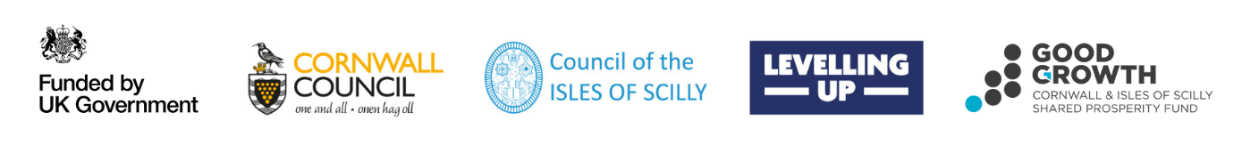

ENDS

Media Enquiries
Rebecca Mordan, Artistic Director of Scary Little Girls, is available for interview.
All requests to be directed to:
Lauren Webb
Roscoe Communications
lauren@talktoroscoe.com
07915 083079

Photography
Images can be downloaded here – picture credits are on each image.

Editorial Notes
About Scary Little Girls
Scary Little Girls is a feminist production hub with a passion for stories that are historically or culturally excluded, or usually told from one perspective only. We actively create jobs for women, cross-collaborating and skills sharing for the benefit of the artistic and wider community and are committed to the creative case for diversity.
SLG employs around 100 artists annually, reaches live audiences of 25,000, creating both indoor and outside work and collaborating and touring with artistic partners, commissioners, pubs, libraries, town councils, and venues from Penzance to John O Groats. The diversity of our projects is unified by our overriding belief in the power of stories to change society, our love for our audiences and our dedication to improving human and women’s experiences.
This gives us a unique, wide reach, despite being a small organisation, and a devoted, growing audience who demand that we keep innovating and risk-taking.
Shared Prosperity Fund
The UK Shared Prosperity Fund is a central pillar of the UK Government’s Levelling Up agenda and provides £2.6 billion of funding for local investment by March 2025.
The Fund aims to improve pride in place and increase life chances across the UK by investing in communities and place, supporting local business, and people and skills.
For more information, visit https://www.gov.uk/government/publications/uk-shared-prosperityfund-prospectus.

